User Stories

#1 Art Teacher

As a creative preschool teacher, I want to be able to write on the screen when I move my pen.

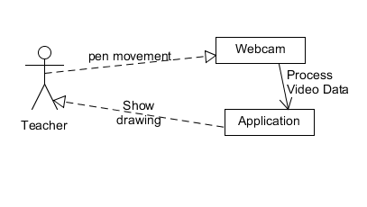

#2 Manager

I have a bunch of markers in my house, so I want the app to fit my specific marker color. I also want it to track whatever I have at the moment so settings for which to track is what I need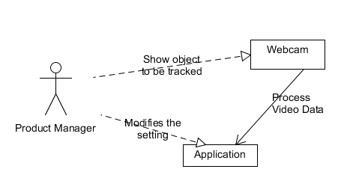

#3 Science Teacher

I want my diagrams to saved to an image file so I can share my diagrams to my students when I conduct an online lecture

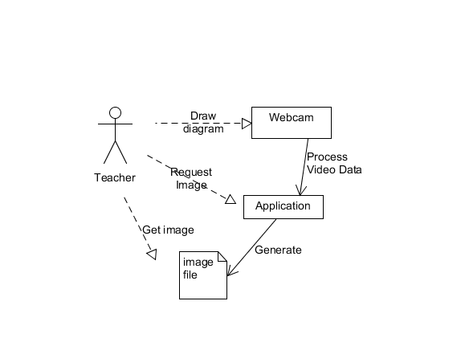

#4 Teacher

I make a lot of mistakes, so I want it to have a feature that gives me the ability to erase sections of my diagrams

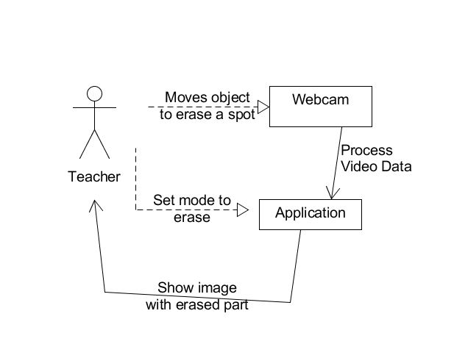

#5 Student

I am always busy, so I want the program to go straight into the board when launched

